WEEK-10
Name:k.venkat ganesh Date:18/11/22
Roll.No: 20r21a05k5

1)Write a c program that illustrate communication between two unrelated process using named fifo.
PROGRAM:

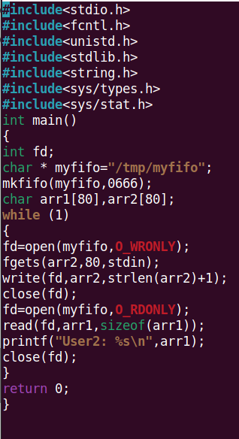
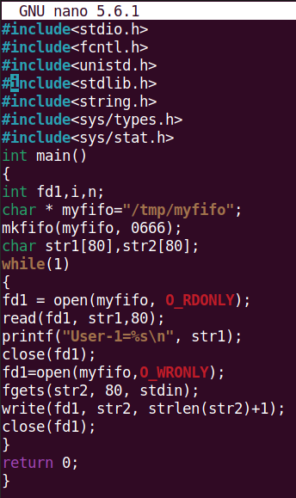
SENDER: RECIEVER: OUTPUT:

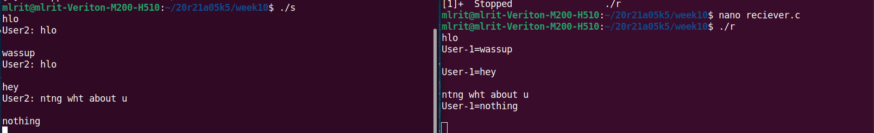

2)Write a c program that illustrate communication between two unrelated process using named fifo.
PROGRAM:
READ: WRITE:
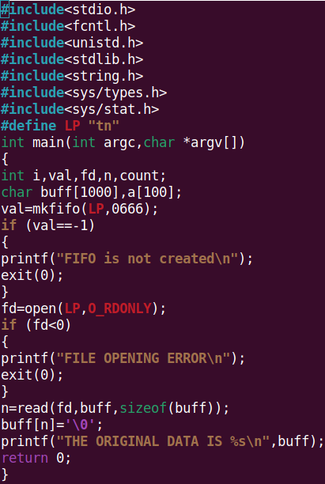
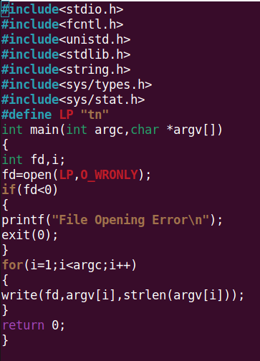

OUTPUT:

